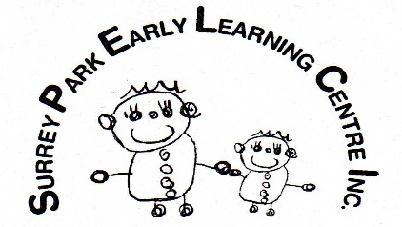 OCTOBER OFFICE Newsletter 2023

Nga mihi o te wa kia koe me te whanau. Greetings to you and your family.
Welcome to the fourth school term at the centre- it is hard to believe that soon we will be in the Christmas shut down period. 2023 has been a very quick year!
END OF YEAR SHUT DOWN: The centre will close at 3pm on Friday 22 December. For the children who have made a booking for the priority week, the centre re-opens for the combined age group of children in the Te Rito area on Monday 15 January at 8.15 am and closes at 4.45pm for the 4 days through to Thursday 18th. The centre is closed on Friday 19 January for our teacher's only day.
All rooms will be open on Monday 22 January 2024 with the normal operating hours of 730am –5.30pm daily.
NEW ACCOUNT CODES: Just a reminder to please make sure you have updated the new code for your payments so we can process the accounts correctly at our end. If you have done this already, we are very grateful as it speeds up the invoicing process.
ENTRY/EXIT WAYS: Please make sure you firmly shut doors and gates in the centre when you are coming in and out of the centre. We have some very quick young children, and they have an eagle eye for escape routes. Please help us keep all children in the right place by giving your attention to the doors and gates.
SIGNING IN & OUT: The Ministry requires you to sign your child in and out daily. The funding is confirmed by the parents' signatures and the last thing we need is for the Ministry of Education to take away our precious funding because a parent hasn’t signed. We also use these sign sheets as our check of who is in the building when there is an emergency, so it is really important you make signing in and out a daily habit. We also ask that you keep your figures for the times as neatly written as possible. Somedays it is very hard to decipher and may mean you get over charged.
STAFFING: Our ACC toll continues to affect us- Claire has returned to work but Karyn Flett has now joined the list with Mike and Penny. We are really excited to welcome 2 graduates from Otago university who will begin their teaching career with us. Summer Richards and Jorja Mineur will begin their time with us in late October.
LABOUR DAY: The centre will be closed on Monday 23 October for Labour Day.
NAMED CLOTHING: We would appreciate it if you could name your child’s clothing. There are so many children with the same clothing it makes it very difficult to sort clothing to the right owner if the clothing is not named in some way. Also, with the supposedly summer weather on its way a change of clothing is useful in case we have water play.
CALENDARS: Thank you to the families who have purchased calendars etc. There are a couple of families who have said they did not get their calendar orders in. We have opened a new order for these, which will close midnight on Monday the 16^{th of} October using the same codes that you have previously been given, which can also be found under child notes in Story Park.

E noho mai- stay well and look after yourselves.
Avril

