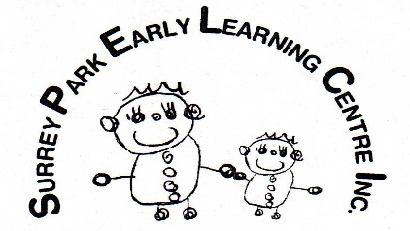 SEPTEMBER OFFICE Newsletter 2023
Nga mihi o te wa kia koe me te whanau. Greetings to you and your family.

POLYFEST. Many thanks to the pre-school team for their great efforts in coordinating 60 of our pre-school children onto the stage to sing their chosen songs. They did so well and I think all the tamariki enjoyed their time on stage.
START & END OF DAY ROUTINES: Thank you for your support with our change of routines to start and end the day. We are finding the Te Rito room far more suitable for the larger numbers of younger children that we have at the end of the day.
END OF YEAR CLOSING: For those of you getting your end-of-year plans sorted, the centre will close at 3.30 on Friday 22 December 2023.
START DATES FOR 2024: We will open in the week starting 15 January 2024 for a small number of children whose parents need bookings. These bookings are done on a first in first booked basis. You will be charged for your booking regardless of attendance as we are bringing staff in from their annual leave to cover this period. This will be a mixed age group of children in the Te Rito room with a collection of staff from throughout the centre, not necessarily a teacher from your child’s home room. The hours of operating for this week are 8.15am – 16.45pm. We will be open Monday to Thursday and closed on Friday 20th for our professional learning day for our teachers.
The” Early Week Form” will follow this email. Hard copies can be found at the office.
STAFFING:
It is with sadness I need to let you know that we will be farewelling Mamta Arora on Friday 22 September. Mamta is off on an adventure to experience living and working in Auckland. Mamta has become a very valued member of the Surrey Park team, and while we wish her well for this new chapter in her life, we will miss her greatly. We are hopeful that the strong family ties Mamta has in Southland might see her return when she has had her adventure in Auckland.
We also have had to say adieu to Monique who is taking time out for health reasons. We wish Monique a speedy recovery and hope that she will be able to return to us soon.
A FEW REMINDERS:
- NAMED CLOTHING: With summer approaching it becomes even more important to have your child’s clothing named. There are so many children with the same clothing it makes it very difficult to sort clothing to the right owner if the clothing is not named in some way.
- CHILDREN’S BAGS: The children’s bags can be kept in the rooms and accessible to the children. We ask that you please avoid putting medication, sweets, or snacks in their bags as we don’t want them to get into the wrong hands. If you do have special things in their bags, please tell the staff and we will make sure the bags are placed out of the children’s reach.
CALENDARS: The calendars have reached their destination for production so hopefully within the month they will be available for you to order online. We will forward you the link once we receive the confirmation, they are ready.

E noho mai- stay well and look after yourselves.
Avril

